



September 2025 Information to all Optimist sailors and families for the 2026 Toyota Optimist NZ Championships
New Plymouth Yacht Club is looking forward to welcoming all the Optimist sailors and families at the upcoming 2026 National Championships.
Please take note of the following information.
Dates:
Good Friday 3rd April 2026
Measurement, and Registration from 8am to 6pm

Saturday 4th
Official Welcome and Briefing 9am. All sailors must attend.
Support Boat Briefing following the sailors briefing. All support boat
drivers must attend.
Green Fleet briefing 10am
Racing from 11.00am for Open and White Fleets, 11.30am for Green Fleet

Sunday 5th to Tuesday 7th April incl
Scheduled Racing with Prize giving after sailing on Tuesday 7th April.

Venue:
New Plymouth Yacht Club
Ocean View Parade, New Plymouth
Website https://www.npyc.co.nz/events/opti-nats/ will have information about the regatta.

Sponsors
We want to thank our generous sponsors.
Toyota New Zealand – for all the support for youth sailing
Port Taranaki – for the wonderful support of the club
Incafe Coffee – For wonderful organic coffee each morning

Accommodation information:
Book a Bach, Holiday Homes, and Air BnB all have local houses to rent.
There are also three close Holiday Parks:
Belt Road Seaside Holiday Park,
2 Belt Rd, Moturoa, Phone 0800-804-204, info@beltroad.co.nz
Has cabins and units, 1 km walk along foreshore walkway to club.
NP Top 10 Holiday Park,
29 Princes St, Fitzroy 0800-758-256, info@nptop10.co.nz
Has cabins and units. About 7kms drive to Club
Fitzroy Beach Holiday Park,
1d Beach St, Fitzroy, Phone 06-758-2870, bookings@fitzroybeach.co.nz
Has cabins. About 7 kms drive to club

Entry forms:
Entry to the Nationals will be via the link on the club website regatta page. There will be a button for entries at the top of the regatta webpage once the NOR has been approved by YNZ. Please ensure that your entry and full payment is made prior to 1 April 2026. Late entries or payments will not be accepted.

Support Boats:
All support boats that are coming to the regatta must enter their details prior to arrival on the online registration at:
https://docs.google.com/forms/d/e/1FAIpQLSf4eqBS2-y3ExAG1gOYQWv1LAoAfy0qbMOZLDPSR9Dq7S7_4Q/viewform
All Support boat drivers must attend the briefing on the morning of Saturday 4th April.

Results:
All results will be uploaded to the regatta page on the website so please share the links so your family and friends can see your progress.

Communications:
Our Club website regatta page will be posting all relevant information, including the Notice of Race, Sailing Instructions, Health and Safety Procedures, Programme, and results link. During the actual regatta, all information will be posted on our official physical club noticeboards. We will also post information onto a WhatsApp sailors’ group, all sailors will be able to scan the QR code for the App at Registration. All Judge and Protest Committee information will be posted on the WhatsApp.
If you need any other information about the regatta, please email our Commodore on npyccommodore@gmail.com. No question too big or too small.

Cold weather
Please ensure your sailors bring their warm gear esp. beanies. New Plymouth in April is usually colder than Auckland.
Sailors must expect to get wet while launching and retrieving yachts on the beach.

Northern sailors travelling
We can recommend a stop at Piopio Berry Orchard. This is located just north of Piopio which is south of Te Kuiti. It is open 9am to 6pm and has great coffee, berry ice-cream’s, fresh berries in season and good toilets. It is on the right-hand side of the road so take care when pulling into their carpark/drive.

Parking:
We will arrange for the grass area on the left of Ocean View Parade and across from the club carpark to be opened for cars and road trailers from Good Friday morning. This area will be locked each night by the security team. If you are bringing a Race Management or Support rib, please park in the club carpark when you arrive, and we will instruct you about overnight storage. See the map at the end of this information for locations we will be using. All Optimists yachts must be stored in our club compound for the duration of the regatta.

Race Area
The club is right on the beach and will give excellent viewing of the Green Fleet racecourse area. Generally, the harbour is flat water with no real current. The Open and White Fleets will be sailing outside the harbour confines.

Club facilities:
The club is a large building with a covered deck right on the sand of Ngamotu Beach. It will be used as the base for all regatta activities from Registration to Prize Giving. Toilets, showers, and plenty of space for your gear is available.
We also have free Wi-Fi available in the beach area curtesy of Primo. The link is “Free Primo Hotspot.”
Please note that there will be NO space for club tents at the regatta. Our compound will be full of the Optimist yachts and sail storage etc. The grass area next to the club is not able to be used for tents due to Council and Port restrictions. There will be ample space in the club for all sailors and their gear.
Parents might also be interested to have a look at the two harbour cameras available to the public.
The Primo “Chimney North East” webcam on https://primo.nz/info/primo-webcams
And the NP Sportsfishing and Underwater club webcam https://www.npsuc.co.nz/webcam

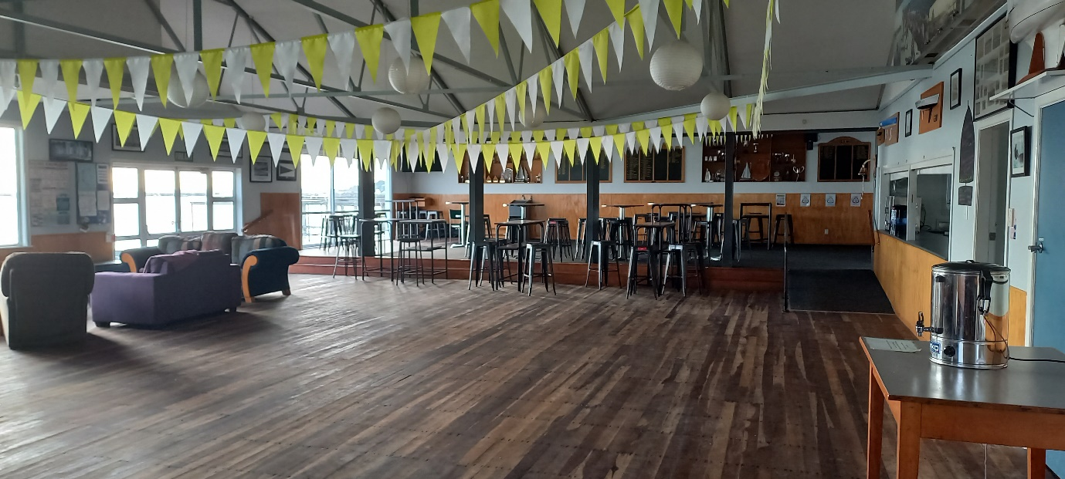

During sailing days, we will have a barista working in the mornings with coffees and hot chocolates available. We would appreciate it if you brought your keep cups to save on takeaway cup rubbish volumes. Our thanks to IncaFe Coffee for their generous support of the club and local sailors.
We will also have Bacon and Egg Butties available each morning.
Please BYO water bottles.
The club takes cash, Eftpos, paywave and credit cards. Note there is a 2.0% surcharge for paywave and credit cards.
The Moturoa shops are just up the road from the club. There are lots of food options namely: good cafes, an excellent hot bread shop, a small 4 Square, Domino’s Pizza, a Kebab shop and a fish and chip shop.
There is also a pharmacy, a doctor, and a BP service station amongst other shops.
The closest Supermarket to the club is Woolworths Spotswood. The central one-way streets in New Plymouth also have Woolworths, New World and Pak’n’Save.

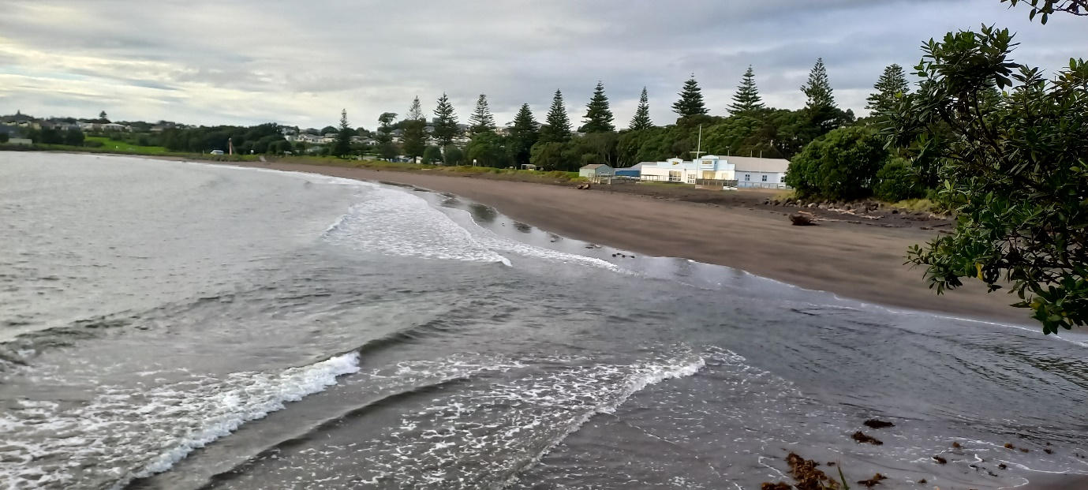

Activities:
New Plymouth has lots to offer by way of activities for sailors and their families.
We recommend a visit to:

Pukekura Park and Brooklands Zoo,
Destination Kawaroa Playground,
Puke Ariki Museum and library with information centre.
Todd Energy Aquatic Centre,
Len Lye centre and Govett-Brewster Art Gallery, housed in the famous reflective building by the clock tower.
Walking and biking on the Coastal Walkway with the Wind Wand
Te Rewa Rewa Bridge
Climbing Paritutu Rock for views of the city, coast, and Back beach sand dunes
East End Skatepark,
Bowlarama with tin pin bowling, black light mini putt and laser tag
Hillsborough Car Museum with mini golf and luge
For the gardening inclined, Pukeiti, Tupare and Hollard gardens
Plus, our fabulous Mountain with walks at North Egmont, Dawsons Falls and the new Manganui Gorge Walk with the stunning 100m long suspension bridge.

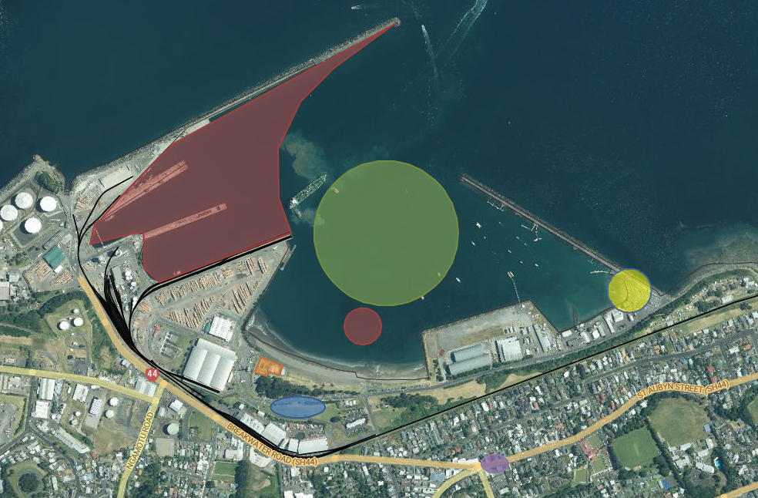
Map of the local area and harbour.

Red Zone Out of Bounds (Port and reef)
Blue Vehicle and Road Trailer Parking
Green Indicative Racing area for Green Fleet
Yellow Public Launching Ramp for RIBs
Orange New Plymouth Yacht Club
Purple Moturoa Shops

