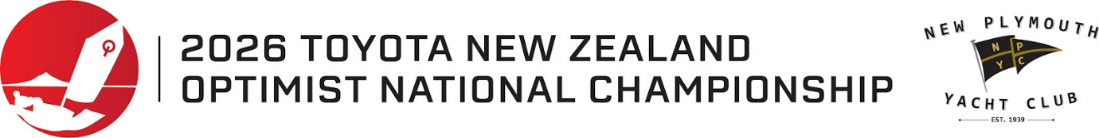



March 2026 Information to all Optimist sailors and families for the 2026 Toyota Optimist NZ Championships
New Plymouth Yacht Club is looking forward to welcoming all the Optimist sailors and families at the upcoming 2026 National Championships.
Please take note of the following information in addition to the information on the September Information to sailors.

Entry forms:
Please ensure that your entry and full payment is made prior to 1 April 2026. Late entries or payments will not be accepted.

Support Boats:
All support boats that are coming to the regatta must enter their details prior to arrival on the online registration form and all boat drivers must attend the briefing on the morning of Saturday 4th April.

Results:
All results will be uploaded to the regatta page on the website so please share the links so your family and friends can see your progress.

Parking:
We have arranged for the grass area on the left of Ocean View Parade and across from the club carpark to be opened for cars and road trailers from Good Friday morning. This area will be locked each night by the security team. Please ensure you have a trailer lock and do NOT leave any items on your trailer that are not secured as the area is open to the public.

If you are bringing a Race Management or Support rib, please park in the club carpark when you arrive, and we will instruct you about overnight storage. Again please ensure your trailers and ribs are secure.

All Optimists yachts must be stored in our club compound for the duration of the regatta.

Club:
Please remember that there will be NO space for club tents at the regatta. Our compound will be full of the Optimist yachts and sail storage etc. The grass area next to the club is not able to be used for tents due to Council and Port restrictions. There will be ample space in the club for all sailors and their gear.
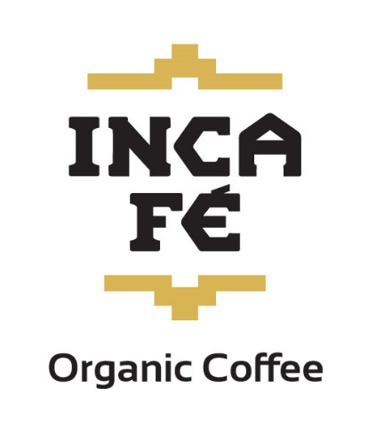
During sailing days, we will have a barista working in the mornings with coffees and hot chocolates available. We would appreciate it if you brought your keep cups to save on takeaway cup rubbish volumes. Our thanks to IncaFe Coffee for their generous support of the club and local sailors.
We will also have Bacon and Egg Butties available each morning.
Please BYO water bottles.
We will have a free hot food item for all sailors once they have finished sailing for the day. And hot food available to purchase from our kitchen for parents and sailors at the end of the day. The bar will also be open selling soft drinks and other drinks after sailing.
The club takes cash, Eftpos, paywave and credit cards. Note there is a 2.0% surcharge for paywave and credit cards.

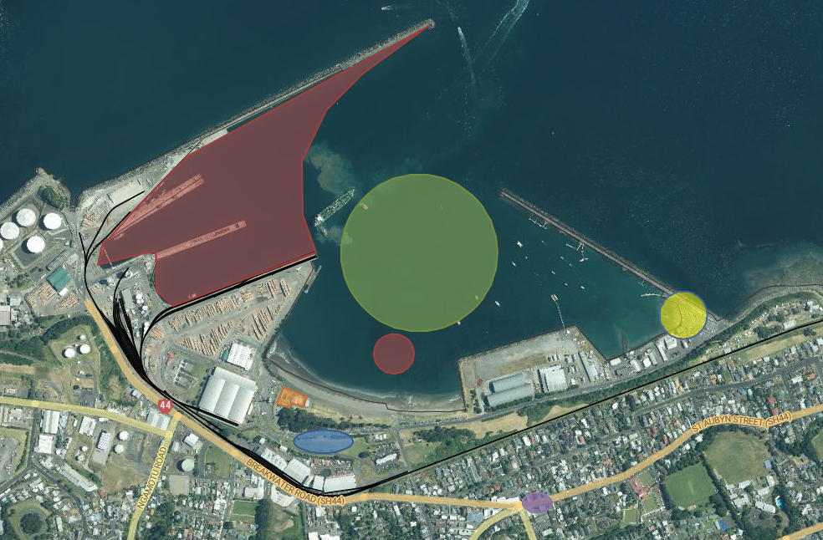
Map of the local area and harbour.

Red Zone Out of Bounds (Port and reef)
Blue Vehicle and Road Trailer Parking
Green Indicative Racing area for Green Fleet
Yellow Public Launching Ramp for RIBs
Orange New Plymouth Yacht Club
Purple Moturoa Shops

