March 2024 Information to all School teams for the 2024 Secondary School Teams Racing Nationals
New Plymouth Yacht Club is looking forward to welcoming all the NZ teams at the upcoming Nationals.
Please take note of the following information.
Email addresses: Please share this information and links to all your team. If there is anyone you wish to be sent our emails directly then please let us know.
Communications: Our Club website regatta page will be posting all relevant information over the next 2 months. During the actual sailing week all information will be posted on our official physical club noticeboards. We will also upload information to the website and the Stack TeamApp which is being setup. The links for these are:
https://www.npyc.co.nz/events/nzss-teams-racing-nationals-2024/
Stack TeamApp: NpycTeamSailingNats2024
If you need any other information about the regatta, please email npyctreasurer@gmail.com. No question too big or too small.
Sailing Instructions: These are now available on the regatta webpage.
Health and Safety procedures: The NZTSA procedures are also on our webpage. Please ensure you have read them. In particular, be aware of the implications of
Sailing Instruction 23.4.

Entry forms: Entry to the Nationals is via the link on the club website regatta page. There is a button for entries at the top of the regatta webpage. Please ensure that your entry and full payment is made prior to 31 March. Late entries or payments will not be accepted. There is no discount for South Island teams per NZTSA requirements for 2024.
Once we have received your online entry, we will contact your Principal to confirm their approval. This is a School Sport NZ requirement.
You can request an invoice for the entry fee of $2,300 either by detailing on your entry or emailing us at npyctreasurer@gmail.com. Please allow enough time for your school payments system to process the invoice before 31 March.
Registration: Please note that there is no team weigh-in at registration, but the coach or manager will be required to sign a declaration about any weights to be carried under NOR3.4.
Results: All results will automatically be uploaded to the regatta page on the website and app from the results programme so please share the links so your family, friends and school mates can see your progress.
Photos: As per prior years there will be a photo of all competitors on Monday morning 22nd April in front of the Yacht Club. As required by School Sport NZ if you have any sailors that do not wish to have their photos taken, please advise us on your entry.
Parking: We have arranged for the grass area on the left of Ocean View Parade and across from the club carpark to be opened for team vehicles from Sunday afternoon. This area will be locked each night by the security team. If you are bringing a Race Management rib, please park in the club carpark when you arrive, and we will instruct you about overnight storage. See the map at the end of this information for locations we will be using.
Club facilities: The club is a large building with a covered deck right on the sand of Ngamotu Beach. It will be used as the base for all regatta activities from registration to Prize Giving. Toilets, showers, and plenty of space for your gear is available.
We also have free Wifi available in the beach area curtesy of Primo. The link is “Free Primo Hotspot”.
Parents might also be interested to have a look at the 2 harbour cameras available to the public.
The Primo “Chimney North East” webcam on https://primo.nz/info/primo-webcams
And the NP Sportsfishing and Underwater club webcam https://www.npsuc.co.nz/webcam

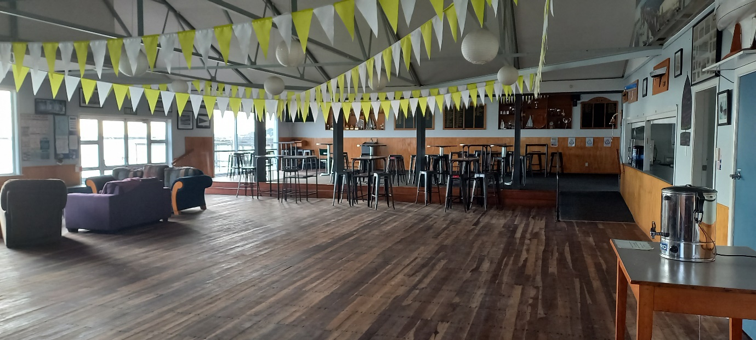
During sailing days, we will have a barista working with coffees and hot chocolates available. We would appreciate it if you brought your keep cups to save on takeaway cup rubbish volumes. Our thanks to InCafe Coffee for their generous support of the club and local teams.
We will also have some snack food available.
Please BYO water bottles.
The club takes cash, Eftpos, paywave and credit cards. Note there is a 2.5% surcharge for paywave and credit cards.
The Moturoa shops are just up the road from the club. There are lots of food options namely: good cafes, an excellent hot bread shop, a small 4 Square, Domino’s Pizza, a Kebab shop and a fish and chip shop.
There is also a pharmacy, a doctors and a BP service station amongst other shops.
The closest Supermarket to the club is Countdown Spotswood. The central one-way streets in New Plymouth also have Countdown, New World and PaknSave.
We will be happy to assist any camp mum/dad with food shopping locations.
Changeover System: It is our intention to sail the Nationals inside the Harbour confines. We do not have a large team holding vessel like the Jane Gifford or the Ocean Rogue of Algies Bay. As such, please be aware that our system will be that all teams will be based in the club building during the regatta.
The 6 sailors that are due to sail next will be taken from in front of the club out on transfer ribs to changeover ribs. The team will stay on the changeover ribs until they swap onto their 3 yachts for racing. Once they have finished racing (usually 2 back-to-back races) they will go back onto the changeover ribs and then onto the transfer ribs for transport back to the beach.
Sailors must expect to get wet getting on and off the transfer ribs as these will come into the beach. Unfortunately, we do not have a jetty for transfers.
All reserves, coaches, and managers etc will always remain on the beach/at the club. All team gear, chilli bins etc can be kept at the club.
Our changeover Co-ordinator will be on the club deck with a PA system so all teams will know when they need to go out to the course.

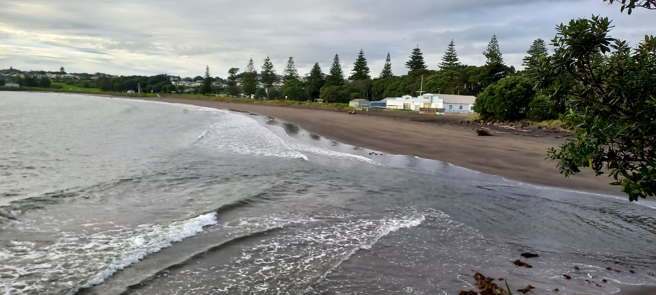

Team Accommodation: We hope you have all found and booked your accommodation. We understand that NP Girls High hostel still has spaces available. See earlier information on webpage for their details.
Also, Egmont Eco Leisure Park of Clawton St has rooms available as another team has just pulled out. Their phone is 06-753-5720 and www.egmont.co.nz.

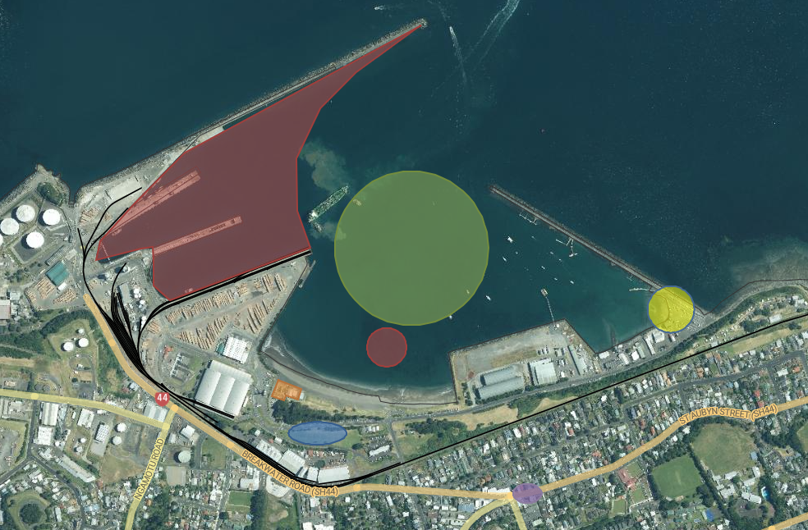
Map of the local area and harbour.

Red Zone -Out of Bounds (Port and reef)
Blue – Team Vehicle Parking
Green Zone - Indicative Racing area
Yellow – Public Launching Ramp for RIBs
Orange – New Plymouth Yacht Club
Purple – Moturoa Shops (BP, Hot Bread Shop, Pizza, Four Square etc

